Ideation Phase
Empathize & Discover

Date | 16 June 2025
Team ID | LTVIP2025TMID53099
Project Name | OrderOnTheGo
Maximum Marks | 4 Marks

Empathy Map Canvas:
Understand the needs, frustrations, and behaviors of food delivery customers looking for a fast, reliable, and user-friendly way to order from nearby restaurants through a platform like OrderOnTheGo.
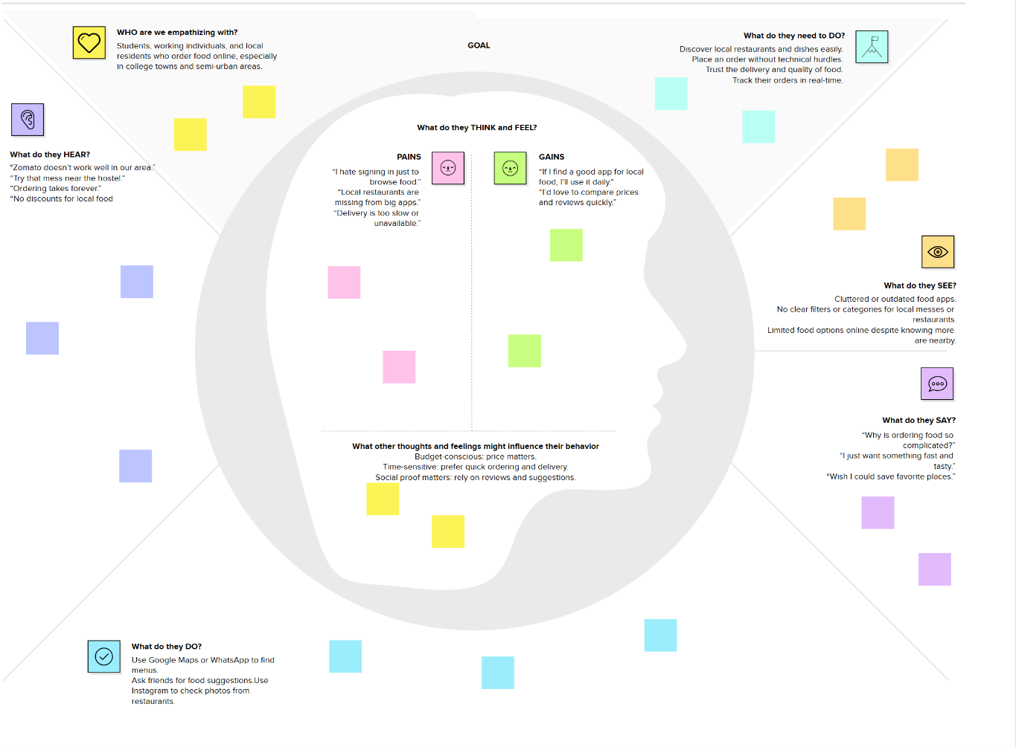

Link: https://drive.google.com/file/d/1yQEOG0dL-F2P0-dDkEkdlSZa-Z9WdqNI/view?usp=sharing
Reference: https://www.mural.co/templates/empathy-map-canvas

